Vision Foundation
In 2021, the Vision Foundation celebrates its centenary anniversary. To mark this significant milestone, we have set ourselves the challenge of raising
£1,000,000 to support blind and partially sighted people into work.

The benefits of work are unquestionable. Employment:
- keeps people challenged and active;
- gives people a sense of pride, identity and personal achievement;
- enables people to socialise, build connections and find support;
- provides financial independence so that people are able to support themselves and explore their interests.

Unemployment can have a devastating effect on people’s health. Issues include:
- higher than average rates of physical and mental health problems;
- greater use of medication and medical services; shorter life expectancy.

Yet within the sight loss community, employment rates are staggeringly low, with just one in ten people who are registered blind in work. Blind and partially sighted people have the right to work like anybody else – the opportunities just need to be unlocked.

The Vision Foundation’s Centenary Appeal will:
- reach 4,000 blind and partially sighted people – one in ten of London’s visually impaired community who are unemployed;
- invest in local, tailored services provided by grassroots organisations;
- transform employer attitudes through campaigns and targeted partnerships;
- unlock the best technology and mobility support.

We believe in a future where people living with sight loss are equal citizens. It is only through access
to meaningful employment that we will achieve equality, inclusion, and independence.

With your help, we can make London a global exemplar of a sight loss aware city.

Centenary Appeal Board Members:

- Heather Goodhew (Co-Chair)
- Naqi Rizvi (Co-Chair)
- Lisa Binks
- Rob Challis
- Ian Davies
- Richard Farr
- David Gold
- Harry Harris
- Alan Pickering CBE
- Gavin Prentice
- Cathy Shorthouse

Foreword

“Supporting the visually impaired community by raising awareness
and affecting positive change is very close to my heart. I’ve been blind since I was seven and I’ve been able to pursue my dreams because of some people who had faith in my abilities and were willing to take the risks.
It deeply saddens me to know that 75% of partially sighted people of working age in the UK are unemployed, which doesn’t only mean a lack of financial independence, but also lower confidence, more isolation and greater disparity in the community.
Can you believe that you can fill 500 buses to capacity with unemployed visually impaired people in London? To me, that’s a travesty of what we stand for as a society.
I know that we can give back a lot if given a chance. All it takes is the willingness to change the status quo and belief that disability is not the same as inability.
I had enormous struggles in my own life as people often associated a lack of sight with a lack of vision. Through determination, patience and the support of my loved ones, I graduated as an engineer and have built a full-time career in financial services.
I want to use my expertise and lived experience to make a positive difference to the sight loss community in London and beyond. I believe so much more is possible for blind and partially sighted people and hope you’ll join me on this journey.”

Naqi Rizvi
Co-Chair of the Vision Foundation Centenary Appeal Board

“In London today, there are more than 40,000 blind and partially sighted people of working age who are not in work. They face many barriers to employment: the assumptions of potential employers; a lack of access to the right technology; unsafe commutes; and low confidence from repeated rejections. For working-age people with total sight loss, these mean the unemployment rate is a staggering 90% – compared to 20% for their sighted peers.

With a hundred years of experience and a helicopter view of sight loss services
in the capital, the Vision Foundation is uniquely placed to tackle these issues. We understand what works and where investment can achieve the greatest impact.
We know that the barriers to employment are eminently solvable with the right services and attitudes. With sight loss in London set to increase by 50% by 2050, plus the greatest economic shock of our generation as a result of the coronavirus pandemic, this has never been more urgent. And with a national workforce which has proven that it can overhaul working norms overnight under lockdown, this has never seemed more possible.

Let’s join forces and create real change. Together we can unlock talent, improve employment and change attitudes. Help us to celebrate a hundred years by paving the way for hundreds of futures.”

Dr Olivia Curno
Chief Executive of the Vision Foundation

The reality facing blind and partially sighted people in 2021

Only a quarter of blind and partially sighted working-age Londoners are in employment (compared to half of all disabled people, and 80% of non-disabled people l

30% of blind and partially sighted people, who are no longer in work, say that they could have continued in their job given the right support.

94% of the public don’t think a blind person could do their job
Figure taken from a YouGov survey, commissioned by the Vision Foundation

Only 1 in 10 registered blind people are in work.
That’s approximately 40,000 unemployed blind and partially sighted people of working age in London.

That’s enough to fill 500 double decker buses of wasted potential.

“As I embark on my first job search since losing my eyesight, there are a number of things that have really struck me, such as the number of large employers that have inaccessible application processes... With 15 years of recruitment experience, if I am finding this challenging, I can guarantee that others are.”

Jurgen, 37
Supported by the Vision Foundation

Our frontline service partners
Each year, the Vision Foundation works with over 35 charity partners supporting over 12,000 blind and partially sighted people across London. Funds raised through our Centenary Appeal will be invested in charities delivering front line, tailored support which improves the employment prospects for blind and partially sighted people in the capital.

In the past year, our partners have included:
Blind in Business - London-wide
The intensive Education to Employment programme, run by Blind in Business coupled with one-to- one coaching, provides practical opportunities for young visually impaired graduates to get into the workplace and step up on the career ladder.

Croydon Vision – covering Croydon and the surrounding areas
Croydon Vision’s dedicated programmes support blind and partially sighted people who are furthest from employment to access intensive support and specialist interventions. They cover key areas such as assistive technology skills, improving mobility skills to travel to and from work independently and maximising residual vision in the workplace.

Look UK - London-wide
Look UK’s mentoring programme works with blind and partially sighted young people at school and in college to help prepare them for their transition to the world of work. Look UK matches young people with mentors who have been through the journey of sight loss at school and are able to provide practical support – from accessible materials, to social groups, and next steps after school.

_____________________________________________

100 years of support
The Vision Foundation was created by Sir Arthur Pearson, founder of the Daily Express, in 1921 under the name the Greater London Fund for the Blind. As someone who had lost his own sight
to glaucoma, his mission was very simple – to ensure the very best help was given to blind and partially sighted people in London.
With many soldiers returning from the First World War having been blinded in battle, and the poor health of the nation leading to a surge in sight threatening conditions, the Vision Foundation was founded to co-ordinate the resources needed to help blind and partially sighted peopled regain their independence and ensure quality of life.
Today our purpose remains clear – to transform the lives of people facing or living with sight loss. Since 1921, we have invested more than £31m in grassroots communities, been early investors in pilot innovations that have been scaled to nationwide programmes and amplified the voices of the sight loss community.
Last year alone, we reached over 12,400 blind and partially sighted people through our work, in addition to supporting the education of 57,340 people about the importance of eye health.

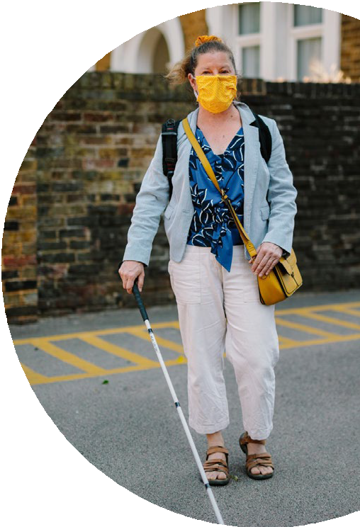
Alan Pickering CBE Centenary Board Member

The impact of COVID-19 for blind and partially sighted people
The coronavirus pandemic is an unparalleled situation that has both divided and united our communities. Lockdowns and ongoing social distancing rules have created physical divisions and considerable challenges for blind and partially sighted people. However, the charitable sector has united in its drive to overcome these challenges.
The Vision Foundation is proud to have collaborated with London Funders and over 60 organisations on the London Community Response Fund by providing expert advice, dedicated support and the commitment of funding.
This period of remote working has shown that with the right technology and employer attitude, almost anyone can work from home.
Blind and partially sighted people have often been ahead of the curve, with their use of changing and
adapted technology over many years. We’ve all had to get to grips with new ways of working and unfamiliar working arrangements – things the sight loss community have been dealing with for decades in order to find work and thrive.
Despite the dark days the pandemic has brought upon the globe, we believe there is light and hope for the sight loss community as we move to new ways of working in 2021 and beyond.

“Lockdown has shown how a flexible approach to employment can increase productivity to the benefit of us all. This couldn’t be truer for the sight loss community who can now benefit from the advances in digital technology and flexibility in working arrangements. The timing couldn’t be better to benefit from this talent pool and get more visually impaired people into meaningful, sustainable employment.”

Why partner with the Vision Foundation?
The Vision Foundation has one hundred years of experience in grant funding and has raised and distributed in excess of £31 million.
This track record, combined with our expertise in investing in the most effective sight loss projects in the capital, means we are the perfect partner for individuals and organisations wanting to drive social change at the heart of some of London’s most disadvantaged communities.
We work collaboratively across the sight loss sector with policy makers and community leaders to ensure our grant giving delivers more than just financial aid. We drive change, we unite the sector and we evolve as the sight loss community needs us to. We know that, together, individuals can make an enormous impact.
Partnering with the Vision Foundation provides an unrivalled opportunity to unlock the talent and aspirations of blind and partially sighted people. In doing so, we can play our part in improving the social mobility of disadvantaged communities across the board.

Your gift has the power to change lives

£5,000 could pay for a two-day employment programme for 20 blind and partially sighted young people, combining adventure and teambuilding with networking, interviews and a mock assessment centre.

£15,000 could support 35 blind and partially sighted people who are furthest from the job market to get the help they need. The programme builds confidence, offers practical assistance and encourages connections, providing a route into both volunteering and paid employment.

£33,000 could pay for a London Employment Advisor for a full year to help employers gain a more informed understanding of the potential and capabilities of blind and partially sighted employees. This project boosts levels of employment and retention, ensuring greater social, cultural and economic inclusion for approximately 80 Londoners with sight loss.

Recognising your support
The Vision Foundation feels strongly about paying tribute to our supporters, but we also recognise that everyone has a unique view on what this means to them. We will discuss personalised recognition options with you, putting your views and wishes at the heart of our plans

“Being blind myself, I want to challenge perceptions about what people believe blind people can do and be a role model for other visually impaired people.”
Monica

To find out more about our Centenary Appeal, please contact:
Monica Smith
Centenary Appeal Manager
msmith@visionfoundation.org.uk
FINALIST
Breakthrough of the Year #BlindLockdownLife
WINNER
Great Giving Award
WINNER
Rising Leader of the Year Olivia Curno

Connect with us:
Call us: 020 7620 2066
Email us: hello@visionfoundation.org.uk
Websitwww.visionfoundation.org.uk
@Vision_Fdn
@VisionFdn @Vision_Fdn
Registered charity number: 1074958
12 Whitehorse Mews, 37 Westminster Bridge Road, London, SE1 7QD

