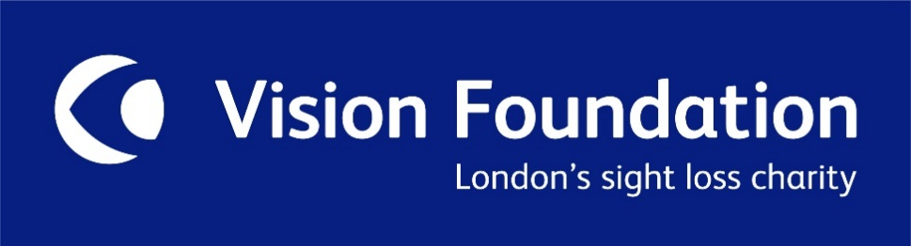
PRESS RELEASE
04 January 2021
CHARITY BENEFITS FROM ART SALE ALMOST 50 YEARS AFTER BENEFACTOR’S DEATH
London’s leading sight loss charity is benefiting from a legacy almost 50 years after the benefactor’s death.
The Vision Foundation, formerly the Greater London Fund for the Blind (GLFB), has found itself at the centre of a poignant and intriguing story of lost art, Nazi persecution and post war politics, thanks to the generosity of Irma Löwenstein Austin who fled Vienna for London soon after Germany’s annexation of Austria in 1938.
Irma and her husband Oscar Löwenstein were prominent members of Vienna’s Jewish community in the 1920s and 30s and owned a large collection of fine art. In 1938 they were forced to divulge their artworks under the Nuremberg Laws* and these were sold under duress. Oscar died soon after reaching London and Irma later remarried, outliving her husband and with no children of her own. When she died on 24 April 1976, she left the majority of her estate to the GLFB.
In 2018 three paintings by Ferdinand Georg Waldmüller, one of the most influential Austrian artists of the Biedermeier period (1815 to 1848), came to light in German galleries. They were known to have been part of the Löwenstein collection which had been intended for the Führermuseum in Linz. As Irma Löwenstein Austin’s heir, the Vision Foundation had rights of restitution.
In May 2019, with pro bono advice from international law firm Charles Russell Speechlys’ (CRS) specialist art lawyers on the complex cross jurisdictional interplay of Austrian, German and English law, the three Waldmüllers were formally restituted to the Vision Foundation by the German Federal Government. Explains CRS art lawyer Tim Maxwell, “A tragic yet fascinating case and a wonderful legacy, the restitution of these artworks was complex and required careful navigation of various laws.”
Two of the paintings, Preparing the Celebration of the Wine Harvest and The Grandparents’ Visit, were brought to auction at the Dorotheum in Vienna with the help of art advisors Cadell + Co who, recognising the importance of the case to the Vision Foundation, also undertook the work pro bono and advised on the best route to market. The paintings attracted great interest at the 19th Century Paintings Sales on 9 November 2020, selling for a total of €383,900. The third painting, Das gutmütige Kind (Der Bettler) (the good-natured child (The Beggar) will be auctioned at the Dorotheum in spring 2021 with an estimate of €150,000 – 200,000.
“It is very rare for a charity to be the benefactor in a restitution case of this nature. We felt truly humbled,” says Tamsin Baxter, Director of Development at the Vision Foundation. “After everything Irma Löwenstein Austin must have gone through in her life, it is truly remarkable that almost 50 years since her death she is still supporting a cause that meant so much to her during her life. Our pledge to Irma is that these paintings will be used for good through our work with blind and partially sighted people.”
Charity incomes have been greatly affected by the global pandemic and the Vision Foundation is no exception as CRS art lawyer Rudy Capildeo explains, “The power of this legacy could not be more profound for the Vision Foundation during these unprecedented times.”
Irma Löwenstein Austin never gave up hope of being reunited with her art collection and continued to try to track down paintings and sculptures which had been seized by the Nazis. Foreign Office correspondence from after the end of the war reveals that while she had the support of the British, French and American representatives on the quadripartite Restitution Committee of the First Bezirk (District) of Vienna on her claim, this was blocked by the Soviet representative. Although she succeeded in bringing some pieces to London and proceeds of their sale went to the GLFB on her death, there are still many pieces unaccounted for.
The Vision Foundation has documents from 1938 including Irma Löwenstein’s application for an export permit, stamped by the Nazi controlled Central Office for Monument Protection, a photograph of Der Bettler hanging in her Vienna apartment and facsimiles of the Foreign Office correspondence showing her efforts to reclaim her art.
*The Nuremberg Laws were anti-Semitic and racist laws enacted in Nazi Germany on 15 September 1935.
Ends here
THE VISION FOUNDATION is London’s leading sight loss charity supporting the city’s best projects for blind and partially sighted people. In 1921 the charity was set up to support and give a voice to blind and partially sighted people across London. The charity celebrates its centenary anniversary in 2021 and is launching its biggest fundraising appeal in its history; to raise £1m to fund employment projects for blind and partially sighted people in the capital.

With a mission to make London a shining example of a sight loss aware city, the Vision Foundation works to transform the lives of people facing or living with sight loss by funding projects which inform, empower and include. Over the last 99 years, they have distributed more than £30m to sight loss organisations to fund vital innovative projects that are changing lives. www.visionfoundation.org.uk

CHARLES RUSSELL SPEECHLYS is a leading international law firm with a dedicated top tier art law practice. www.charlesrussellspeechlys.com

CADELL + Co is a specialist art advisory firm regulated by the UK Financial Conduct Authority. www.cadellco.com

For further information relating to the Löwenstein legacy, the documents referred to above and to interview spokespeople from the Vision Foundation, Charles Russell Speechlys and Cadell + Co please contact: Mark Ellis, Head of Communications at the Vision Foundation, mellis@visionfoundation.org.uk; 07971 435632.

