Director of Retail

The Vision Foundation has been supporting and speaking out on behalf of blind and partially sighted people across London for close to 100 years.
Formerly known as the Greater London Fund for the Blind, we support organisations that provide a necessary lifeline and essential resource for London’s visually impaired community.
But people living with sight loss in the capital are facing significant and growing challenges, and ever worsening life chances. Meanwhile, a very high and growing number of people are needlessly going blind. We have identified that the Vision Foundation can play a critical and unique role in both saving sight and transforming lives by working in partnership with others to deliver projects which inform, empower, and include.
A new strategy, launched along with our new name in October 2019, gives us the opportunity to have more impact than ever before. We will work to improve the opportunities, wellbeing and inclusion for blind and partially sighted people. We will do more to ensure London is open and welcoming to the visually impaired community across employment, and social and cultural spaces. We will strive to reduce loneliness and isolation. And we will ensure that blind and partially sighted people further marginalised through homelessness, poverty or domestic violence are reached. Above all, we will emphasise what people can do, rather than what they can’t.
But our work is more than just providing support. It’s also about amplifying voices to ensure that blind and partially sighted are heard. And it’s about changing our society and the systems that structure it, by inspiring more people to advocate and take action.
We are looking to recruit an exceptional Director of Retail to provide strategic direction and leadership to modernize and grow our trading operations. The Director of Retail will support a passionate and committed retail team to deliver profit, promote fundraising and support eye health and public awareness. They will ensure that the business is run in a robust, transparent, compliant and efficient way in line with our values – whilst contributing expertise and energy to the Executive Team.

The role demands a great blend of skills, along with the belief that every blind and partially sighted Londoner should be able to lead their life to the full. As an equal opportunities employer, the Vision Foundation welcomes applicants from all backgrounds irrespective of race, religion, belief, gender, disability, age or sexual orientation.

Our Vision and Values

Our vision is a future where people living with sight loss are equal citizens and preventable blindness is a thing of the past.

Our mission is to make London a shining example of a sight loss aware city.

Our purpose is to transform the lives of people facing or living with sight loss by funding projects which inform, empower and include.

Our values
Our values reinforce everything we do. They shape the way we work and the culture we endeavour to instil.

We collaborate
The problems we seek to address are complex – no one organisation can do it alone. We wish to learn and share knowledge, combine skillsets and expertise, amplify impact and enable innovation.

We empower
It is individuals with sight loss who have the insight, skills and experience to identify the most important issues, influence others, and bring about lasting change.

We work intelligently
The issue of sight loss spans research, health, stigma, employment, culture, sport, transport, safety, economics, equality and more. Without an intelligent, evidence-based approach, our efforts will not be focussed to bring about the greatest impact.

We are courageous
Sight loss is a growing, urgent problem. Every day, people needlessly lose their sight for life. Every day, people unfairly miss out on opportunities. Every day, people face abuse, disregard, isolation, poverty and depression. We must be brave today to bring about a brighter tomorrow.

The Role: Director of Retail

Responsible to
Chief Executive

Direct Reports
Head of Retail Operations

Location
Central London

Working Hours and Contract
Full-time, permanent

Salary
£45,000 - £55,000

JOB PURPOSE
We are looking for a Director of Retail with the passion and experience to lead the charity’s retail business to deliver funds and awareness in support of social change for people living with and facing sight loss in the capital.

Strategy, planning and growth

- Continually review, refine and develop retail activity in line with the organisational Strategic Plan 2019-24.
- Track progress against plans and budgets, and support teams to adapt, phase and prioritise work where appropriate.
- Ensure that broad and long-term thinking is brought to decision making and avoid reactionary behaviour, whilst capitalising on arising opportunities.
- Contribute to the work of the wider organisation, contributing to our decision-making as a member of the Executive Leadership Team.
- Refine and deliver the three-year Retail Strategy (2020 – 2023), including:
  - The professionalisation of our systems and processes to capitalise on all income opportunities.
  - Putting a positive customer experience at the heart of our approach.
  - Delivering income upwards of £1m per annum with year on year growth to £1.5m by 2024.
  - Implementation of EPOS and Gift Aid across all shops.
  - Shop-by-shop refit and rebrand in line with our new brand identity.
  - Identify, secure and launch 1-2 new shops each year.
  - Utilise digital and social media to drive footfall and stock donations.
  - Working with the fundraising team, develop corporate partnerships to support stock donation.
  - Support fundraising through the shops, including legacy and IG marketing.
  - Tailor each shop in the portfolio to maximise the potential of its unique location and its role in the business – including exploration of clearance, vintage, furniture and books.
  - Create a framework of retail standards of excellence and ensure shops and online are managed and maintained to those standards.
  - Explore new income products and routes, including lottery products, online sales, and bought goods.

Leadership and management

- Support members of the charity retail team to embed a high performing, motivated, collaborative, creative and dynamic culture – and seek opportunities to celebrate success.
- Continuously analyse risks, potential, changes in environment and charity retail trends; and use to inform plans.
- Provide line management, leadership and growth opportunities to the Head of Retail Operations and their reports.
- Support new starters with comprehensive induction and training.
- Establish appropriate and proportionate performance targets beyond weekly shop takings.
- Define and develop our retail volunteer programme to ensure first rate volunteer experience, engagement, and great customer experience.
- Support the annual appraisal and probation processes for all staff.

Governance, finance and operations

- Report regularly to the Trustee Board, Trading Board, and Finance, Audit and Risk committee.
- Understand and mitigate risk in the context of charity retail and multi-site working.
- Ensure timely and accurate performance reporting to ELT and Board.
- Develop annual budgets, report variance and reforecast as appropriate.
- Develop and maintain up to date policies and procedures and ensure
- these are embedded across the shops operation.
- Co-ordinate and manage the retail property portfolio, including acquisitions, closures, leases, utilities, refurbs and rent reviews.
- Engage professional advisors including agents, surveyors and solicitors as appropriate.
- Maintain up to date knowledge of charity law affecting retail and advice on emerging issues.
- Ensure all retail income is raised lawfully, including data protection legislation, Charity Commission guidance and Fundraising Standards/Charity Retail Association codes of practice.
- Ensure compliance with all relevant legislation including Trading standards, Health & Safety, fire and building regulations for the retail premises, ensuring annual inspections and training of all staff and volunteers.

Impact

- Explore opportunities to deliver the wider impact of the charity through the “shop front” of our retail portfolio, including employment, volunteer and training placements for blind and partially sighted people.
- Support eye health messaging through the shops.
- Support public awareness and understanding about visual impairment and visually impaired people.
- Share with customers the impact of the funds raised through shopping with us through in store communications, staff training and social media.

PERSON SPECIFICATION

Experience
- Proven ability in retail management delivering significant sales and profit growth across multiple sites, ideally in a charity retail context
- Proven track record of opening new shops
- Proven experience of developing and managing budgets
- Experience of EPOS systems
- Experience of managing online selling operations
- Experience of setting and managing comprehensive income and expenditure budgets
- Experience of commercial property leases and shop fitting
- Experience of leading and line managing others to develop and grow, and building and maintaining a high performing team culture

Personal Qualities
- Calm, supportive and strategic approach to leadership
- Ability to manage high volumes of varied work and operating to tight deadlines
- Intelligence and enthusiasm
- An understanding of and commitment to London’s sight loss community
- An excellent communicator, able to present complex information clearly in oral and written form, and to inspire and enthuse others
- Excellent organisation and planning skills
- Entrepreneurial approach – experience of developing new products, markets and channels
- Positive, resilient and supportive of others
- Ability to assess and balance risk and opportunity
- Emotional intelligence and excellent listening skills
- Committed to equal opportunities and inclusion
Organogram:
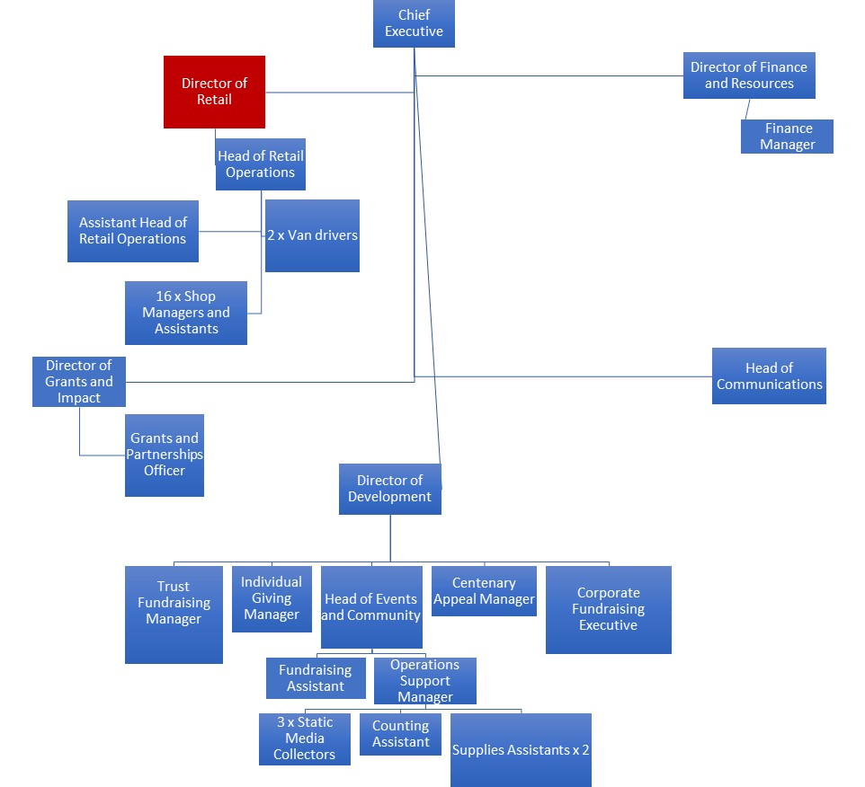

Plain text organogram:
Chief Executive

Director of Retail

Head of Retail Operations

Assistant Head of Retail Operations

2 x Van drivers

16 x Shop Managers and Assistants

Director of Finance and Resources

Finance Manager

Director of Grants and Impact

Grants and Partnerships Officer

Head of Communications

Director of Development

Trust Fundraising Manager

Individual Giving Manager

Head of Events and Community

Fundraising Assistant

Operations Support Manager

3 x Static Media Collectors

Counting Assistant

Supplies Assistants x 2

Centenary Appeal Manager

Corporate Fundraising Executive

How to Apply
Please submit a CV and supporting statement to hello@visionfoundation.org.uk by 5pm on the 30th January 2020. First interviews will be held in the week commencing 3rd February, and second interviews in the w/c 10th February.
Vision Foundation
Johns Mills House, 12 Whitehorse Mews,
27 Westminster Bridge Road
SE1 7QD
Tel: 020 7620 2066

